**HORECACCESS**

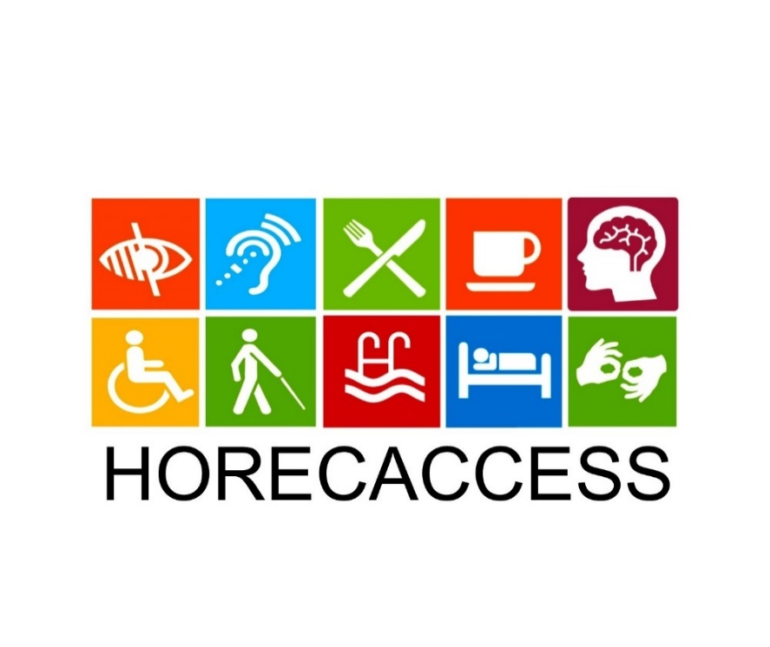

Structured guidelines on provision of accessible and reliable services to clients with disabilities IO3- **HANDBOOK**

For further information, related to the HORECACCESS project, please visit the project’s website at <https://horecaccess.eu/>or visit us at <https://www.facebook.com/pg/HORECAccess/>.

Download our mobile app at <https://play.google.com/store/apps/details?id=com.horecaccess.mobile&hl=en>.

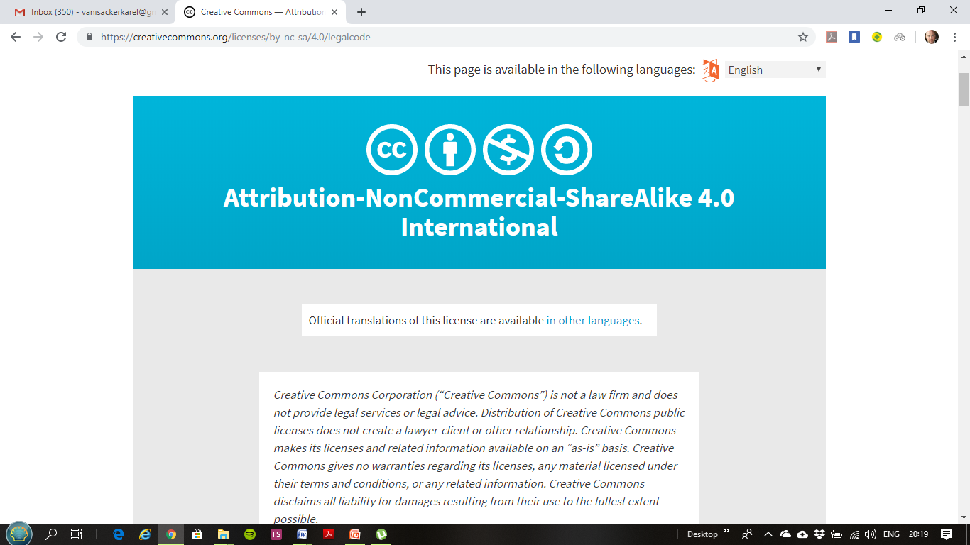

This project (HORECACCESS project - 2018-1-BG01-KA202-047904) has been funded with support from the European Commission (Erasmus+ Programme). This publication reflects the views only of the author, and the Commission cannot be held responsible for any use which may be made of the information contained therein.

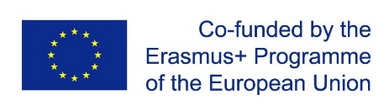

Contents

1 Introduction 3

1.1 Why provide accessibility? 3

1.2 Difference between Disability and Impairment 4

1.3 Cases where appropriate and inappropriate handling of costumer with disability 5

2 Disability Legislation and Legal requirements for Disability Equality 16

2.1 European Level 16

2.2 Belgium, Bulgaria, Serbia and Turkey 17

3 GUESTS WITH MOBILITY IMPAIRMENT 21

4 GUESTS WITH VISUAL DISABILITIES 22

5 GUESTS WITH Hearing DISABILITIES 24

6 GUESTS WITH COMMUNICATION DISABILITIES 26

7 GUESTS WITH LEARNING DISABILITIES 28

8 GUESTS WITH DEAF-BLINDNESS DISABILITIES 29

9 GUESTS WITH THE Autism Spectrum Disorder 31

10 DEALING WITH GUESTS WITH DISABILITIES OVER THE PHONE 33

11 General information to provide a better service with any guest with Disabilities 34

References 37

# 1 Introduction

Traveling is one of the best experiences that life can give to a person. Through traveling, people canget to know new places, new languages and 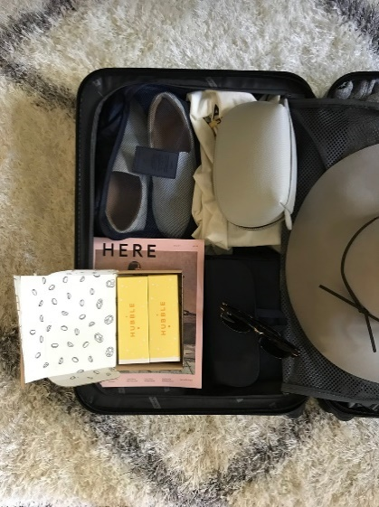new cultures, to expand their knowledge and visions about life.

So, if something is so edifying and constructive, why people with disabilities and impairments have difficultiesto experience this kind of thing in their day to day life?

We do not always think about it, but many people with disabilities and impairments fail to travel because of the lack of accessibility in the hotels/resorts where they spend their days and even the lack of accessibility in many historical monuments, beaches, restaurants, bars or attractions of the place intended for traveling.

The purpose of this handbook is to provide a document with public access for the use of management, personnel and new staff; and which all staff should be aware of. Itspurpose is to provide a simple way of listing and explaining information of the needs thatguests might need to be provided by the whole establishment’s team.

## 1.1 Why provide accessibility?

We live in a diverse society, where social inclusion is becoming a worldwide issue and the demographics are changing; in particular the population is ageing and there is increased level of immigration. Fifteen percent of the world’s population, around one billionpeople experience some type of disability or some kind of impairments like pregnant woman, older people, obese people, guests with injuries, etc.

Providing accessibility will be additional not only for the guests and society but also for the tourism market, financially.

## 1.2 Difference between Disability and Impairment

A disability can be defined as a condition which may restrict an individual’s mental, sensory, or mobility functions. It does not mean that a person with disability is unable to perform and live a normal life, but that they need some adjustments or support for better living.

A person with disabilities is a person with an impairment who experiences disability. Disability is the result of negative interactions that take place between a person with an impairment and her or his social environment. Impairment is thus part of a negative interaction, but it is not the cause of, nor does it justify, disability.

A disability may be caused by an accident, trauma, genetics or disease, which may restrict a person’s mental process, sense or mobility.

People with disabilities are present in all ages, colors, sex and cultures, just like everyone else. The only thing that can be seen as different is that people with disability might be unable to do certain things in the same way as the mainstream of society. They may require some form of adjustment or assistance inovercoming the obstacles which disturb their functioning.

A person with impairment can be because of an injury, illness, or congenital condition that causes, or is likely to cause, a loss or difference of physiological or psychological function. But in a society perspective we should all look at each other as human beings, does not matter the impartment or disability, we all deserve to be treated with respect and by respect means being able to come and go anyplace we desire and experience the wonderful things life can offer.

Example: David is a person who has consequential state caused by form of cerebral palsy (CP) called spastic diplegia. David's CP causes his legs to be stiff, tight, and difficult to move. He cannot stand or walk.

**Impairment:**The inability to move the legs easily at the joints and inability to bear weight on the feet is an impairment. Without orthotics and surgery, David's level of impairment may increase as imbalanced muscle contraction over a period of time can cause hip dislocation and deformed bone growth.

**Disability:** David's inability to walk is a disability. His level of disability can be improved with physical therapy and special equipment. For example, if he learns to use a walker, with braces, his level of disability will improve considerably.

## 1.3 Cases where appropriate and inappropriate handling of costumer with disability

**APPROPRIATE:**

1. 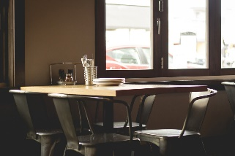Kerry J: I had a lovely experience at a restaurant. I stated that my son has ASD and noise bothers him, when they had offered a table right in the middle of the restaurant and busy thoroughfare. So the staff seated us at the side of the restaurant and opened the side door, so my son did not feel so hemmed in. I think if the staff has knowledge and are educated about different conditions, I believe that the majority would be happy to assist. *(Facebook Group: Intellectual Disability Support Group for Parents and Loved Ones)*
2. 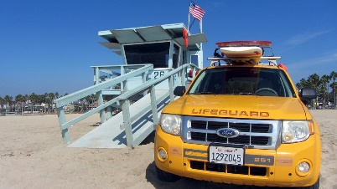Christina G: We’ve vocational at a Summer Cap a few times now. One time, they made sure to have an ASL (American Sign Language) interpreter available for my youngest daughter in the evening programs. Last summer, when my oldest daughter had a seizure in the water, their lifeguards and staff were amazing. They knew exactly how to respond and I felt so secure and calm. We will go back again because of the great staff they have. *(Facebook Group: Disability Wisdom Discussion Group*)
3. 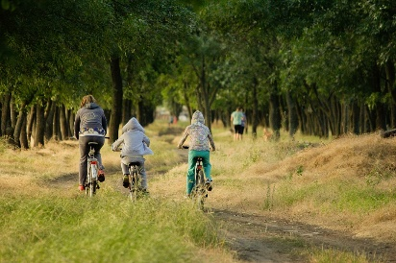Liz C: My son with ASD goes every summer to a bike Summer Camp and the owner/guide makes sure to advice my son on social tips, as it is my son desire to not allow anyone to know he has autism. My son has very difficult time during school year and he is always looking forward going to this camp, where he has friends and a more active social life as he desires. We love the entire staff and how they are understandable about my kid situation and support and help him always when there is a need. *(Facebook Group: Disability Support Group*)
4. 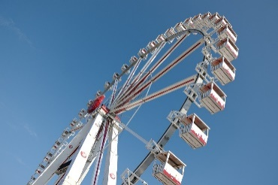Karlen P: I have twins with ASD and we went to a theme park and we told about the kids condition and they offer a wristband, which allow us to ‘cut’ the line and each child can have two adults as companions, which was just great, because my parents were with us and we could go in rides all together, the kids had a blast with no meltdowns. People are the park would complain to see 6 people cutting the line, but that’s out right and one of the mom’s said something rude to me and I just answered back that she has no idea how bad I wished I could be standing in line with my children, with them just being okay with that. *(Facebook Group: MotivACAO Caio e Enzo*)
5. 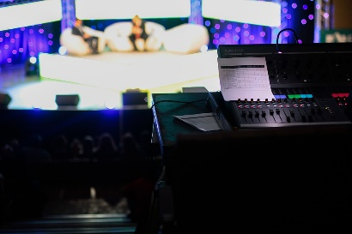Nikki S: I have Autism Disorder and I was at ‘this morning live show’ with my mother in law. I was a career for her back then. My mother in law was and still disabled. She had 3 brain tumours removed, one being in her brain stem. She was lucky she had managed to learn to walk again, but assisted. So we were at the show and my mother in law needed to go to the toilet. We walked across to the disabled toilet and someone was in there. We waited. She came out and was a young girl and not disabled. We ignored her and went in. There was no toilet paper so we had to leave to get some from the ladies restroom and as we walk back the same girl went back to the disabled toilet. I knocked on the door and said ‘excuse me, you are not disabled’ and she cursed at me and kicked the door and did not come out. I told one of the security guards who escorted her off the premises. So the moral of the story is that the staff were great and everyone helped my mother in law to get around with ease.*(Facebook Group: Disability Support Group*)

1. Edin B: Visiting as an unaccompanied power chair user it's always hard to know how you're going to get on in places you've not been to. Costa at Cameron Toll was great as there was a low counter, the staff were friendly and helpful, and the access great. The staff get a full score as they were welcoming and helpful from the start. It was no big deal for them to carry my coffee across to the table, see if I wanted anything else, and juggle the furniture to help me sit where I wanted. *(Source:* [*https://www.euansguide.com/venues/costa-coffee-edinburgh-4109/reviews/good-coffee-in-a-relaxed-atmosphere-2187*](https://www.euansguide.com/venues/costa-coffee-edinburgh-4109/reviews/good-coffee-in-a-relaxed-atmosphere-2187)*)*

1. 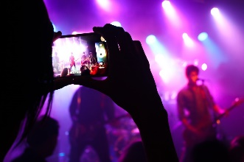Unknown: I was at a bar and they were playing live music and then I felt the need to pee and then I thought “well it is time to feel embarrassed”, I called for the waitress and asked him to help pull me to a car that was far in the parking lot so I could pee and then the waitress said to me “we have bathroom here!” and I answered with just one question “I know. But will enter my wheel chair?” and for my surprised he answer “It does. It was me who organized everything and I asked to the bathroomto be accessible for wheel chair users. The owners did not want, because they thought it would be more expansive, but I insisted a better bathroom for all.” Nowadays I am a regular client. *(Source:* [*http://www.eumed.net/rev/cccss/22/consumidores-com-deficiencia-motora.html*](http://www.eumed.net/rev/cccss/22/consumidores-com-deficiencia-motora.html)*)*
2. 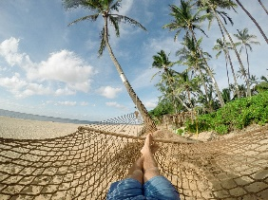Unknown: When I feel my best is when I am at hotels or resorts, even though it is not adapted for me, most of the staff do not treat me like a “weak/poor” person, I do not know if it is by the fact that as I am hosted so it means I can pay for it, so the staff just treat me normal.” *(Source:* [*http://www.eumed.net/rev/cccss/22/consumidores-com-deficiencia-motora.html*](http://www.eumed.net/rev/cccss/22/consumidores-com-deficiencia-motora.html)*)*
3. 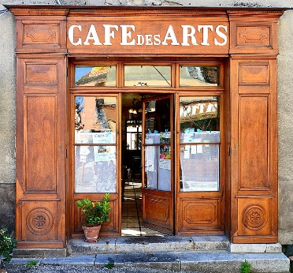Annette Nielsen: I went to a restaurant and I called them when I arrived the door because there was a step to enter the door, then two guys from the staff came and set up the mobile ramp, which they struggle bad to set up properly so I can go through. When I was inside I went to the elevator (as the restaurant in the second floor), was a delightful evening. *(Source:* [*https://www.postandcourier.com/food/we-dined-with-wheelchair-users-at-of-charleston-s-top/article_f3452f38-8531-11e8-9456-dbb4fa08ede7.html*](https://www.postandcourier.com/food/we-dined-with-wheelchair-users-at-of-charleston-s-top/article_f3452f38-8531-11e8-9456-dbb4fa08ede7.html)*)*
4. Sadie: It was here that I saw why The Gate was named autism-friendly. He was patient with me, giving me time to process and not asking me difficult questions. Clearly he knew how to deal with the situation and make it as easy for me to be there as possible. *(Source:* [*https://www.ambitiousaboutautism.org.uk/understanding-autism/out-and-about/sadie-reviews-the-gate-restaurant*](https://www.ambitiousaboutautism.org.uk/understanding-autism/out-and-about/sadie-reviews-the-gate-restaurant)*)*
5. 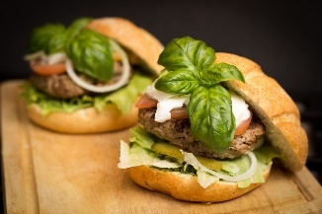Unknown: We struggle to find local and delicious restaurants that are autism friendly. Well MAHEK is definitely one of them, Not only is the food absolutely fresh and delicious the service is great and the staff are friendly. They always make us feel comfortable when we go with our son who struggles to sit still, can make a little mess on the floor and can also shout out a lot of the time.*(Source:*[*https://www.tripadvisor.in/ShowUserReviews-g635914-d3315269-r430317836-Mahek-Cheshunt_Hertfordshire_England.html#*](https://www.tripadvisor.in/ShowUserReviews-g635914-d3315269-r430317836-Mahek-Cheshunt_Hertfordshire_England.html)*)*
6. Unknown: I fell in love with this place (restaurant) the minute I stepped through the front door. Their crepes were OUT OF THIS WORLD!! I loved how Deaf friendly it was, and how it's entirely run by Deaf people! No barriers. *(Source:* [*https://www.tripadvisor.com/ShowUserReviews-g30196-d10392445-r395350107-Crepe_Crazy-Austin_Texas.html#*](https://www.tripadvisor.com/ShowUserReviews-g30196-d10392445-r395350107-Crepe_Crazy-Austin_Texas.html)*)*
7. 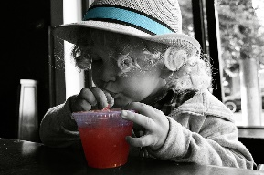Eleanor: As a night out without kids, we decided to check this restaurant out after walking past a few local places to eat. After being promptly seated as it was early on in the evening, we were offered the menu immediately. We discussed what we wanted to have in sign language. I was pleasantly surprised that we had the owner approach us and stated conversing with us in Thai sign language. We were able to exchange information to make the choices of our dishes for the evening, we also noticed the dishes were reasonably priced and had a variety of dishes to choose from. As I wasn't a fan of chili, I was able to select one that suited my taste while my husband chose one with a kick added to it. *(Source:* [*https://www.tripadvisor.com/ShowUserReviews-g297930-d1106159-r529200435-The_Orchids_Restaurant-Patong_Kathu_Phuket.html#*](https://www.tripadvisor.com/ShowUserReviews-g297930-d1106159-r529200435-The_Orchids_Restaurant-Patong_Kathu_Phuket.html)*)*
8. 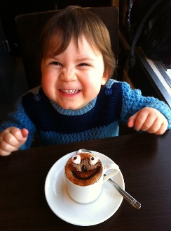Frances: We were in this Cafe today and I was really touched by the warm welcome given to our son. My husband often visits the cafe with him, after a trek through the local charity shops - a favourite pastime for our son! Normally I am not there too, so I was really impressed when my son barged in, as he is won't to do, but was welcomed by name...'Hi, ****! How are you doing?' The staff there know him and happily let him have his own snacks since his diet is incredibly limited. Today we took in a punned of grapes, some of which they took and washed for him, returning them in a bowl. Visiting a cafe with an 18 year old who has autism AND a grandson aged 21 months (neither fully verbal!) could have been tricky...TODAY IT WAS JUST WONDERFUL!! Top marks for such acceptance and welcome! *(Source:*[*https://www.tripadvisor.com/ShowUserReviews-g186525-d1790973-r297332337-Cafe_Plum-Edinburgh_Scotland.html#*](https://www.tripadvisor.com/ShowUserReviews-g186525-d1790973-r297332337-Cafe_Plum-Edinburgh_Scotland.html)*)*
9. 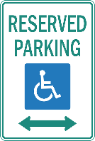Unknown: We did not have a disabled tag on our vehicle but needed to park right in front of the hotel for my son's benefit. Huge thanks to Chani who went out of her way to help us with breakfast - I was very touched by her sincerity and generosity of spirit. *(Source:* [*https://www.tripadvisor.co.za/ShowUserReviews-g312654-d586630-r440168062-President_Hotel-Bantry_Bay_Western_Cape.html*](https://www.tripadvisor.co.za/ShowUserReviews-g312654-d586630-r440168062-President_Hotel-Bantry_Bay_Western_Cape.html)*)*
10. Unknown: We stayed at the President Hotel and had our 6 year old, non-speaking son with us. The staff were great in accommodating our family's special requirements. This made the stay truly memorable for us and we will have no hesitation in recommending to other families. Special call out goes to Nicholas at the front desk who helped us with parking as we did not have a disabled tag on our vehicle but needed to park right in front of the hotel for my son's benefit. Huge thanks to Chani who went out of her way to help us with breakfast - I was very touched by her sincerity and generosity of spirit. *(Source:* [*https://www.tripadvisor.co.za/ShowUserReviews-g312654-d586630-r440168062-President_Hotel-Bantry_Bay_Western_Cape.html*](https://www.tripadvisor.co.za/ShowUserReviews-g312654-d586630-r440168062-President_Hotel-Bantry_Bay_Western_Cape.html)*)*
11. Unknown: We were delighted with this new beachside restaurant. It serves daytime snacks €5 for large white long roll filled with bacon, lontza, grilled halloumi, and local sliced cheese together with a salad garnish. A local large bottle of beer (Leon or keo) is about €3.50. They have a mix of fast food (burgers etc.) and more substantial main courses including steaks pizza, pasta at reasonable prices. There is an accessible toilet, 1 disabled parking space right next to the ramp to the sandy beach. A lovely place to have a meal with plenty so space between tables to accommodate a mobility scooter or wheelchair. The staff are friendly and helpful.*(Source:* [*https://www.tripadvisor.com/ShowUserReviews-g1175196-d4818620-r212301896-Nissaki_Agias_Theklas-Sotira_Limassol_District.html#*](https://www.tripadvisor.com/ShowUserReviews-g1175196-d4818620-r212301896-Nissaki_Agias_Theklas-Sotira_Limassol_District.html)*)*
12. 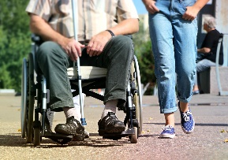Mike: Always a great welcome and we have always been made to feel special by the extremely friendly, welcoming and attentive staff.My wife is disabled and a wheelchair user, it is so important for us to ensure that access is possible and toilet facilities are adequate for disabled guests. Signor Valentino's has an excellent awareness of the needs for their disabled guests. There is room around the entire restaurant for a wheelchair and a very well designed disabled toilet facility. *(Source:* [*https://www.tripadvisor.co.uk/ShowUserReviews-g186460-d732932-r138521507-Signor_Valentino_Mermaid_Quay-Cardiff_South_Wales_Wales.html#*](https://www.tripadvisor.co.uk/ShowUserReviews-g186460-d732932-r138521507-Signor_Valentino_Mermaid_Quay-Cardiff_South_Wales_Wales.html)*)*
13. Carolynn: All staff are friendly and helpful - nothing is too much trouble. The staff all talk to my daughter and though she is PEG fed they always ask if they can get her anything to eat /drink: no assumptions are made. Also opening doors for us on arrival and departure is much appreciated and makes things easier. *(Source:* [*https://www.euansguide.com/venues/the-park-bistro-linlithgow-146/reviews/a-firm-favourite-to-which-we-return-again-and-again-613*](https://www.euansguide.com/venues/the-park-bistro-linlithgow-146/reviews/a-firm-favourite-to-which-we-return-again-and-again-613)*)*
14. Tracey: All of the staff wereso friendly, polite and helpful, we never felt awkward or a nuisance. When we appeared at the exit barrier, if staff did not spot us straight away they apologized profusely. It was such a good experience that by the end of the two evenings my son was able to access the rides accompanied only by his sister, 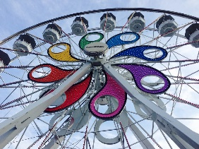as long as I went with him up the exit ramp and waited for him there. This meant that I was able to miss some of the scary coasters, and as a mom with a fear of heights this was a huge relief! So thank you Hershey Park for your wonderful staff, your inclusive ethos and for allowing my son to build his confidence and gain a little more independence. It has meant the world to us. *(Source:* [*https://www.tripadvisor.com/ShowUserReviews-g52819-d107691-r170841300-Hersheypark-Hershey_Pennsylvania.html#*](https://www.tripadvisor.com/ShowUserReviews-g52819-d107691-r170841300-Hersheypark-Hershey_Pennsylvania.html)*)*
15. 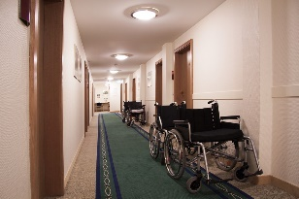Rachel: We came here with work, we brought three autistic wheelchair users and the hotel was fantastic, I would recommend it for adults rather than children as there's a bar and all-inclusive and entertainment every evening. Staff are great and helpful with anything you require. They have hoists beds with sides, shower trollies and chairs and 'it's right near the pleasure beach. I would definitely come back with a group of adults who I work with who have learning difficulties. *(Source: https://www.tripadvisor.co.uk/ShowUserReviews-g186332-d191584-r326172420-Bond_Hotel-Blackpool_Lancashire_England.html)*

**INAPPROPRIATE:**

1. Daryl L: I recently travelled through parts of NW - USA. I think the biggest contrast I encountered was when I travelled through museums in WY. I went into one museum and asked if someone was free to show me around. I was put in a corner ‘out of the way’ and given a phone number for an audio tour, never got to see any exhibits. I walked four or five blocks to the historic Governor’s mansion and was not only given a personal guided tour, but excellent descriptions to boot. *(Facebook Group: Intellectual Disability Support Group for Parents and Loved Ones)*
2. Unknown: Go to the grocery store, the movie theatre, a store in the mall, a restaurant or any public-type place that has employees, and five times out of ten you’ll run into an employee who will automatically assume you’re ill-equipped mentally because of an obvious physical disability. This happens to me constantly, especially if I’m at a grocery store with an able-bodied friend. Every time at check out, the cashier will always ask my friend if she wants paper or plastic, directing all her questions towards her, never assuming I’m the one who’s paying. Very, very frustrating. *(Source:* [*https://www.huffingtonpost.com/tiffiny-carlson/discrimination-people-disabilities-_b_4509393.html*](https://www.huffingtonpost.com/tiffiny-carlson/discrimination-people-disabilities-_b_4509393.html)*)*
3. 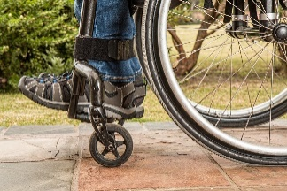Unknown: “Sorry, no more wheelchairs allowed.” Concert venues, airplanes, city buses, amusement park rides — quotas on how many wheelchairs are allowed in certain places are a reality of disabled life. They’re instated for safety, but they’re also highly limiting, generally only allowing a half dozen people with disabilities or so into an event or two people who use wheelchairs on a city bus. These rules can be highly limiting, forcing us to change our plans. Very often when I try to buy tickets for a show, the wheelchair tickets have long been sold out, leaving me no option but to not go. While this isn’t considered illegal discrimination, in my eyes it is just as bad. *(Source:* <https://www.huffingtonpost.com/tiffiny-carlson/discrimination-people-disabilities-_b_4509393.html>)
4. Arthur Lewis: From Shropshire, who was on holiday in Ceredigion with his daughters Katie and Becky, said he struggles to visit local attractions because Katie, 22, has a severe form of cerebral palsy and is completely dependent on a wheelchair. When we went to one tourist attraction in the town, they said Katie wouldn't be able to use it to its full extent. So I thought there's no point in paying for that. *(Source:* [*https://www.bbc.com/news/uk-wales-41066217*](https://www.bbc.com/news/uk-wales-41066217)*)*
5. Mariana: Mom of a child with disabilities called Leo, went to Pizza Hut restaurant and said that the first waitress ignored the presence of her child and did not even put a plate in front of him, then after another waitress came to the table and asked if ‘the boy’ would eat. She was very upset and said that ‘I don’t know if he knows but Leo is a child, not a thing. He feels hunger, thirst…’ She asked for a birthday promotion as she was celebrating her birthday that day with the family and the waitress said he would check with the manager if the 4 people she brought (her husband and 3 children, including Leo) counts, but then the waitress said she would receive another item but not the promotion that the establishment offers for everyone on their birthday when they bring other people to celebrate. The mom said this isn’t the first time it happens to her and tired of it Mariana asked to owners of the place to train better their employees as ‘people with disabilities exist and they aren’t invisible’. *(Source:* [*https://noticias.r7.com/rio-de-janeiro/crianca-deficiente-e-vitima-de-preconceito-em-pizzaria-no-rio-denuncia-mae-24022015*](https://noticias.r7.com/rio-de-janeiro/crianca-deficiente-e-vitima-de-preconceito-em-pizzaria-no-rio-denuncia-mae-24022015)*)*
6. 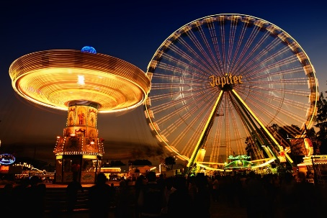Craig G: He visited a theme park and went on a children’s ride with his daughter one of the staff (called Harry) told him as he approached to go sit on the ride to leave his crutch on the side of the wall and get onto the ride. Craig explained to him that he couldn't walk without the crutch and Harry then let him through the gate so Craig and his daughter went around got in the jumbo elephant and put the little chain on with no problem and no safety issues. Craig had my crutch on the outside for Harry to collect (this is what most ride operators would do), at this stage Harry came over to them and told that he wasn't happy with Craig going on the ride as I couldn't walk. Craig explained to him that he had already went on bigger rides and that was a child’s ride. Harry replied with "I'm not doing that you can't walk". This is not the correct response to a disabled person in front of everyone there. He said he was going to call it in and he went off after a long wait. Craig could hear him over the radio saying can’ttake it on the ride so it would have to be left on the side. At this stage Harry came back to Craig and told him to get off because he can't walk (Craig said that he thoughts was ‘how humiliating, everybody was already moaning about why the ride wasn't going’). His wife could then hear them saying as he got off "oh that's the reason there". Craig was not very happy about this as there was no health and safety reason for this action, just Harry’s attitude towards him. At this stage, he got out and told his daughter to stay there as mommy would be coming on instead of him and he started to walk towards the exit and his wife was making her way in through the exit. *(Source:* [*https://www.tripadvisor.com/ShowUserReviews-g580409-d216483-r370608108-Chessington_World_of_Adventures_Resort-Chessington_Surrey_England.html*](https://www.tripadvisor.com/ShowUserReviews-g580409-d216483-r370608108-Chessington_World_of_Adventures_Resort-Chessington_Surrey_England.html)*)*
7. Unknown: In August 2006, in Ponta Delgada, a couple had dinner at the restaurant with their autistic daughter, when she suffered a crisis and began to reveal autistic behaviours. The owner of the restaurant, to whom some tourists had complained about the girl's uneasiness and sounds, asked the couple to leave, because their daughter would be disturbing the other guests. The couple felt humiliated and now wants to know how to react judicially. *(Source:* [*https://www.tripadvisor.com/Restaurant_Review-g189135-d6696858-Reviews-A_Tasca-Ponta_Delgada_Sao_Miguel_Azores.html*](https://www.tripadvisor.com/Restaurant_Review-g189135-d6696858-Reviews-A_Tasca-Ponta_Delgada_Sao_Miguel_Azores.html)*)*
8. Jenna Nielson: A mom was with her two daughters Lara and Melanie who are mentally disabled were at a restaurant and had been golfing with the Special Olympics and were celebrating. "Melanie had yelled a couple of times, nothing a small child wouldn't do," said Jenna Nielson, program manager at Danville Services. Nielson says the manager came over to her and asked if Melanie was OK and gave her a "weird look." "I told him she was fine, and he asked if we were leaving, and I said yes, and he said he'd had complaints," Neilson recounted. (Source: <https://www.ksl.com/index.php?nid=148&sid=17531362&comments=true>)
9. 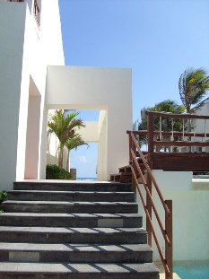Unknown: wheelchair users mentioned the existence of stairs as a barrier to entering or dining in a restaurant. Participants highlighted that even a single stair in front of the restroom can present a barrier. In this context, participants suggested that the staff frequently assumes that wheelchair users can easily climb a single stair. It should also be noted that interviewees using wheelchairs also mentioned that the tables are often not high enough for the wheelchair. *(Source: Dimensions of hotel experience of people with disabilities: an exploratory study, 2010)*
10. Unknown: Wheel chair woman said that: ‘people using wheelchairs need spacious rooms. We take all the furniture out or move it next to the room walls. Then in the morning the housekeeping staff positions it again in the “right place”. Then, we organize the room again. Then, they reposition it. It is a Ping-Pong match, in which all players lose’. *(Source: Dimensions of hotel experience of people with disabilities: an exploratory study, 2010)*
11. 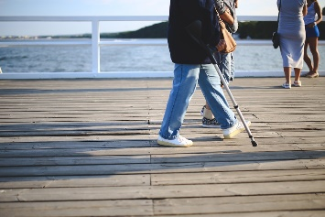Unknown: Crutches user staying in a hotel said: ‘Since implementing this green energy conservation policy, hotels punish us because we use crutches. We [crutches users] throw the towels on the floor, because we do not want to slip and fall. Housekeeping comes back in the morning and takes the towels; however, they then restock the room with fewer towels. Housekeeping needs to understand that we are simply afraid of falling’. *(Source: Dimensions of hotel experience of people with disabilities: an exploratory study, 2010)*
12. Unknown: Blind men in a restaurant said: ‘Sometimes I feel like a baby. The waitresses decides that since she didn’t have a chance to help an old lady cross the street today, she should take care of me. I don’t need this help. She doesn’t need to cut the steak for me or twirl the spaghetti on my fork. Such acts are devastating’. *(Source: Dimensions of hotel experience of people with disabilities: an exploratory study, 2010)*
13. Unknown: Wheelchair user said that: ‘Try to imagine yourself communicating with someone you can only hear. For the money I am paying to finalize my bill, why can’t the reception clerk sit on one of the chairs in the lobby in front of me?’*(Source: Dimensions of hotel experience of people with disabilities: an exploratory study, 2010)*
14. Marka Rodgers: “I’ve called a restaurant from inside the bathroom and asked them to let me out,” says Marka Rodgers, an incomplete quadriplegic who was trapped behind a door too heavy for her to force open with her functional arm. “I don’t expect the world to change 100 percent for me. I don’t expect to take a tour of Charleston’s old houses. But I just want to have a nice time.” *(Source:* [*https://www.postandcourier.com/food/we-dined-with-wheelchair-users-at-of-charleston-s-top/article_f3452f38-8531-11e8-9456-dbb4fa08ede7.html*](https://www.postandcourier.com/food/we-dined-with-wheelchair-users-at-of-charleston-s-top/article_f3452f38-8531-11e8-9456-dbb4fa08ede7.html)*)*
15. Jackson: “I’m not sure if you want us to grade the restaurant, but I’d give it an A-minus,” he writes. He couldn’t give The Obstinate Daughter a perfect grade, he explains, because he didn’t see any signs directing people to the elevator, and even though he asked a server on the outdoor patio to show him the way, nobody greeted him when the elevator doors opened on the dining room. “I’ll give them points for having an elevator though!”*(Source:* [*https://www.postandcourier.com/food/we-dined-with-wheelchair-users-at-of-charleston-s-top/article_f3452f38-8531-11e8-9456-dbb4fa08ede7.html*](https://www.postandcourier.com/food/we-dined-with-wheelchair-users-at-of-charleston-s-top/article_f3452f38-8531-11e8-9456-dbb4fa08ede7.html)*)*
16. Unknown: We made a reservation at Carmela's restaurant in Horsham and let them know my guide dog would be with us. We did this as a courtesy - as a guide dog owner I'm protected by law and can take my dog with me, but we like to warn places so they can put us on a table out the way if they prefer. We were told we would be welcome.When we turned up we were told that we weren't allowed in because my guide dog was with us. They acknowledged that we had booked and told them about the dog but they still wouldn't let us in. *(Source:* [*https://www.tripadvisor.co.uk/ShowUserReviews-g580419-d1873510-r364300974-Carmela_Restaurant-Horsham_Horsham_District_West_Sussex_England.html#*](https://www.tripadvisor.co.uk/ShowUserReviews-g580419-d1873510-r364300974-Carmela_Restaurant-Horsham_Horsham_District_West_Sussex_England.html)*)*
17. 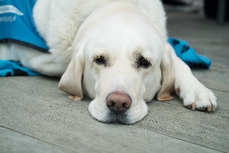Alun: “I was made to feel like a piece of dirt. They told me I couldn't come in because it was against their religious beliefs to have a dog in the restaurant.” (He has a guide dog and wanted to go to a Restaurant in a religious area). *(Source:*[*https://www.telegraph.co.uk/news/uknews/law-and-order/3775993/Blind-mans-guide-dog-barred-from-restaurant-for-offending-Muslims.html*](https://www.telegraph.co.uk/news/uknews/law-and-order/3775993/Blind-mans-guide-dog-barred-from-restaurant-for-offending-Muslims.html)*)*
18. Katrina: My son has Autism and a peanut allergy. The owner kicked us out because my son with Autism was eating food from home at the back of the restaurant. We were out of view from an empty restaurant. Other families sitting outside were feeding their children outside food while parents ate their ordered meals. The owner was uncomfortable with my child with Autism. He told us to leave.*(Source:* [*https://www.tripadvisor.com/ShowUserReviews-g30242-d4581448-r495673526-Bonchon_Chicken_Arlington_VA-Arlington_Virginia.html#*](https://www.tripadvisor.com/ShowUserReviews-g30242-d4581448-r495673526-Bonchon_Chicken_Arlington_VA-Arlington_Virginia.html)*)*
19. Chris: called to Gennaro's Pizza &Italian Restaurant about menu. They asked me for an email address and I gave it to them. Later, they called me return ask me for phone use text which I don't have a phone just Video Phone (VP) for deaf community communicate with order, many etc. Unfortunately, no photos etc. sent to VP. Somehow Gennaro’s Pizza &ItalianRestaurant really RUDE to us because no phone sound like no order then hang up. Why they can't sent to email because they asked me in first place. I will give a 1 stars because they don't have patient if I can't imagine that disability people that how they treat to us as discrimination…*(Source:* [*https://www.tripadvisor.com/ShowUserReviews-g60964-d2324499-r325317029-Gennaro_s_Pizza_Italian_Restaurant-Luray_Virginia.html#*](https://www.tripadvisor.com/ShowUserReviews-g60964-d2324499-r325317029-Gennaro_s_Pizza_Italian_Restaurant-Luray_Virginia.html)*)*
20. Margaret: I took my very disabled sister in law to Nardinis last Wednesday.She is usually in a wheelchair but managed up the ramp on her Zimmer. When we entered we were told that the side of the restaurant nearest the disabled entrancepeoplewas not in use. I pointed out the fact that my sister in law could barely walk, but no, she had to weave through diners, who had to stand to let her pass to a table at the other side of the restaurant. I spoke to the under manager and she said. She could not have let us sit at the side nearest the disabled door as they were short of staff and would not have been able to find us. I wrote an email to the company more than a week ago but have had no reply. *(Source:* [*https://www.tripadvisor.com/ShowUserReviews-g551771-d1484759-r542995908-Nardini_s-Largs_North_Ayrshire_Ayrshire_Scotland.html#*](https://www.tripadvisor.com/ShowUserReviews-g551771-d1484759-r542995908-Nardini_s-Largs_North_Ayrshire_Ayrshire_Scotland.html)*)*

# 2 Disability Legislation and Legal requirements for Disability Equality

## 2.1 European Level

UNCRPD (The United Nations Convention on the Rights of Persons with Disabilities) recognizes in Article 9 that to enable persons with disabilities to live independently and participate fully in all aspects of life, States Parties should take appropriate measures to ensure to persons with disabilities access, on an equal basis with others, to the physical environment, to transportation, to information and communications, including information and communications technologies and systems, and to other facilities and services open or provided to the public, both in urban and in rural areas. These measures, which shall include the identification and elimination of obstacles and barriers to accessibility, shall apply to, inter alia:

a) Buildings, roads, transportation and other indoor and outdoor facilities, including schools, housing, medical facilities and workplaces;

b) Information, communications and other services, including electronic services and emergency services.

States Parties should also take appropriate measures:

a) To develop, promulgate and monitor the implementation of minimum standards and guidelines for the accessibility of facilities and services open or provided to the public;

b) To ensure that private entities that offer facilities and services which are open or provided to the public take into account all aspects of accessibility for persons with disabilities;

c) To provide training for stakeholders on accessibility issues facing persons with disabilities;

d) To provide in buildings and other facilities open to the public signage in Braille and in easy to read and understand forms;

e) To provide forms of live assistance and intermediaries, including guides, readers and professional sign language interpreters, to facilitate accessibility to buildings and other facilities open to the public;

f) To promote other appropriate forms of assistance and support to persons with disabilities to ensure their access to information;

g) To promote access for persons with disabilities to new information and communications technologies and systems, including the Internet;

h) To promote the design, development, production and distribution of accessible information and communications technologies and systems at an early stage, so that these technologies and systems become accessible at minimum cost.

## 2.2 Belgium, Bulgaria, Serbia and Turkey

*Belgium*

Belgian law requires that any new building with public or community space has to be accessible for persons with disabilities.Many existing buildings as well as public transportation systems are less adjusted to individuals with disabilities.

According to rules on the division of competences between various levels of government determined by the federal state, accessibility rules for public places fall within the remit of the Regions. Each Region has drawn up specific regulations on this issue.

Flanders: In Flanders, the Government Order of 5 June 2009 sets out urban planning rules on accessibility. This regulation has been in force since 1st March 2010. 6. With regard to the objectives pursued, the ORPD and organizationsof persons with disabilities regret that only physical accessibility is targeted. As a result, the specific needs of certain groups of persons with disabilities cannot be met.

Walloon Region: Articles 414 and 415 of the Walloon Code on Land Use and Urban Planning, Heritage and Energy (CWATUPE) specify the list of areas and buildings and sections of buildings open to the public or for general use which should be accessible to persons with reduced mobility and the technical and architectural requirements for these buildings and areas

Brussels-Capital Region: Titles IV and VII of the Règlement Régional d’Urbanisme (Regional Urban Planning Regulation - RRU) set out the accessibility standards for public places and buildings.

*Bulgaria*

In Bulgaria the law requires improved access to buildings for persons with disabilities, and new public works projects take this requirement into account; however, this law is rarely enforced in older buildings. Bulgarian law prohibits discrimination against persons with physical and mental disabilities in employment, education, access to health care, and the provision of other state services; however, the government does not effectively enforce these provisions in practice. Societal discrimination persists against persons with disabilities.

Public transportation and general commuting in Sofia or around Bulgaria is nearly impossible for individuals with disabilities. Buses, trams, and trolleys are generally old and extremely crowded, and lack facilities for travellers with disabilitydisabilities. Some newer vehicles claim to have access for people with disability, but in practice, access is extremely limited and travellerswith disability must rely on fellow passengers to help them on and off the vehicles. The Sofia metro is the most accessible system for people with disabilities, but its reach is limited....TravellersTravelers with disabilities should consider traveling with a friend or family member who can assist them in navigating the transportation systems in Bulgaria.

*Serbia*

The government of Serbia in 2015 is adopted “Rulebook on technical standards of planning, design and construction of facilities, which ensure unhindered movement and access to disability, children and the elderly”.This Rulebook sets forth the standards that define mandatory technical standards measures and conditions for planning, design and construction of facilities. Altough, there is lack of data about accessible touristic place, there are some good initiatives such as Map of Accessibility for Public Objects supported by government or good practice that airport staff each year has to pass certificated training for providing personal assistance for the passengers at the airport.

Serbia new buildings are required to be accessible to persons with disabilities, travellers may encounter difficulties in accessing older buildings, outdoor tourist sites, hotels, and public transport. Sidewalks and paths to buildings and tourist sites are often uneven.

Public transport in big towns in Serbia has assistive technologies in the form of speech devices, which is really helpful not only for person with disabilities, but also for visitors from strange tourists. Public transportation is provided free of charge to persons with disabilities under certain circumstances. Travelers should check with the public transportation company in the city they plan to visit to see if they qualify for this service.

*Turkey*

The Turkish constitution prohibits discrimination against persons with disabilities in the provision of state services, employment, education, and access to health care, and the government generally enforces the law effectively. However, the law does not mandate access to buildings and public transportation for persons with disabilities, and access in most cities is quite limited.

Persons with disabilities generally find that Turkish airports and metro stations are easily accessible, but other public transportation, such as buses or taxis are not. There are reserved seats for people with disabilities, pregnant, or elderly people in public buses, but neither the roads nor the buses are designed for easy access for people with disabilities, . In a few big cities, some traffic lights have sound systems for the visually impaired, but these are uncommon.

Roads and footpaths are frequently under construction and may contain extensive obstructions. In addition, vehicles may park on footpaths or otherwise obstruct access to footpaths. While some accessible hotels and restaurants exist in tourist destinations, in general, accessibility for people with disabilities in Turkey is poor.

# 3 GUESTS WITH MOBILITY IMPAIRMENT

Persons with physical impairment disabilities often use assertive devices or mobility aids such as crutches, canes, wheelchairs and artificial limbs to obtain mobility. Mobility impairment is defined as a category of disability that includes people with varying types of physical disabilities.

* Put yourself at **eye level** with a guest using a wheelchair. If possible, **sit next** to the guest when having a conversation.
* **Don't touch mobility aids**, including wheelchairs, without permission.
* Don't assume that a guest using a wheelchair wants to be pushed, **ask first**.
* Make sure there is a**clear path** of travel.
* Ensure there are **no obstructions**, such as counters, between you and the guest. Comearound to the guest side of the counter during your interaction.
* Where an accessible counter is not available, provide a clipboard as a writing surface.
* **Offer assistance** if the guest appears to be having difficulty opening doors.
* If a guest uses crutches, a walker or another assistive device, **offer assistance** with coats, bags or other belongings.
* Offer a chair if the guest will be standing for a long period of time.

# 4 GUESTSWITH VISUAL DISABILITIES

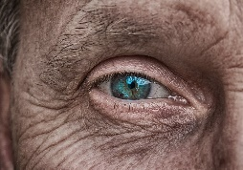Visual impairment, also known as vision impairment or vision loss, is a decreased ability to see to a degree that causes problems not fixable by usual means, such as glasses, etc. Visual impairment may cause people difficulties with normal daily activities such as driving, reading, socializing, and walking.

* **Always ask if assistance is needed**; never assume that a guest who is blind or partially sighted requires assistance. If assistance is requested, **ask how best to assist**.
* **Speak directly to the guest** and **identify yourself** as a representative of the service provider.
* In busy noisy environments, it may be necessary to repeat yourself. When doing so, **ask** for confirmation that the guest understands your instructions.
* Wheelchair assistance should **not** be offered to guests who are blind or partially sighted **as it is not a substitute for guiding**.
* Be clear and precise when giving directions; give the guests**verbal information** (e.g., number of stairs up or down). Pause at obstacles, such as stairs or doors, to announce them to the guests.
* If you are **offering a seat**, gently place the guest's hand on the back or arm of the chair, which will assist the guest to locate the seat.
* **Tell the guest when you are leaving**; never leave a guest who is blind talking to an empty space. Ensure the guest is fully aware of what is taking place.
* When assisting a guest with a service dog, **don't interact with or talk to the dog**. Never pet, feed, or direct a service dog wearing a harness or vest.
* When dealing with monetary transactions, **tell** the guest the denominations when you count the money they are receiving from you.
* **Make sure** that the guest has picked up all of his or her possessions before leaving.
* Ask if the guest needs assistance signing forms – **offer to guide their hand** to the appropriate space for signature. Place an envelope or piece of cardboard just below the signature line to guide them to this space.
* **Offer assistance** if the guest appears to be having difficulty locating a specific service area.

# 5 GUESTS WITH Hearing DISABILITIES

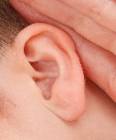People who have hearing loss may be deaf or hard of hearing. Like other disabilities, hearing loss has a wide variety of degrees. People who are hearing impaired may require assistive devices when communicating.

* **Get the guest's attention before you speak**. A gentle shoulder tap is appropriate if the guest is near you, or you can wave your hand if the guest is at a distance.
* **Identify who you are** (e.g., show the guest your name badge).
* Ask the guest about **their preferred method of communication**, and/or whether it would be helpful to communicate by writing using a paper and pen or a computer, tablet, or smartphone.
* To help people who lip-read, make sure there is **no shadow on your face** while you speak.
* Provide sign language interpretation to guests who request it.
* If the guest uses a sign-language interpreter, **speak directly to the guest**, not the interpreter (there is no need to ask the interpreter’s opinion and make sure that the interpreter sits next to you and that the deaf person can see both of you clearly).
* Maintain **eye contact**. Don't look down or sideways.
* **Remove visual distractions** (e.g., don't stand in the front of a bright window and avoid environmental noises).
* **Rephrase** when you are not understood.
* **Be patient** and **prepared to write things down** if you are not being understood or you don't understand.
* **Body language** helps to project the meaning of what you are saying; be animated. Use facial expressions and gestures when appropriate.
* **Don't assume that the guests is wearing hearing aids**.
* Discuss matters that are personal (e.g., disability-related needs or medical information) in a private manner to avoid eavesdropping by others.



# 6GUESTS WITH COMMUNICATION DISABILITIES

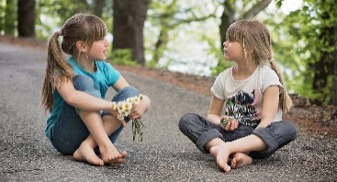Some people have problems communicating. It could be the result of cerebral palsy, hearing loss, or another condition that makes it difficult to pronounce words, causes slurring or stuttering, or not being able to express oneself or understand written or spoken language. Some people who have severe difficulties may use communication boards or other assistive devices.

* **Give the guest time to speak without interrupting them**. Resist the temptation to finish their sentences for them.
* **Watch** and **listen** as the guest may use body language, speech, or a communication device.
* If the guest is having difficulty expressing their needs, **summarize what you have understood**, the guest can then just complete the sentence rather than having to repeat everything.
* **Stay away** from noisy areas (e.g. Conversation of others).
* **Avoid** speaking loudly, this does not help.
* **Don't pretend** to have understood and don't hesitate to ask the guest to repeat themselves.
* **Consider** writing, using a computer, tablet, or cell phone as an alternative means of communicating if you are having difficulty understanding the guest, **but first ask the guest if this is acceptable**.
* If the above strategies do not help, ask questions that require only short answers or a nod of the head. Try to offer a choice of answers to your question to obtain a "yes" or "no". The "yes" and "no" can also be expressed by nodding, pointing at yes-no on a sheet, pointing the thumbs up or down, etc**. You should first ask the guest if this is acceptable**.

# 7GUESTS WITH LEARNING DISABILITIES

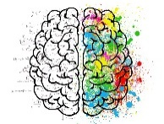Learning disabilities can result in a host of different communications difficulties for people. They can be subtle, as in having difficulty reading, or they can be more pronounced. They can interfere with a person’s ability to receive, express or process information. You may not be able to know that someone has a learning disability unless you are told, or notice the way a person acts, asks questions or uses body language.

* **Offer assistance or extra time to complete forms**, understand written instructions, or make a decision; wait for the guest to accept the offer of assistance – **don't "over-assist"** or be patronizing.
* **Be prepared** to repeat, rephrase or provide an explanation more than once.
* Be **patient**, **flexible**, and **supportive**, take time to understand the guest and make sure the guest understands you.
* If you are not sure what the guest said, **ask** for clarification.
* **Listen carefully** when the guest speaks.
* **Speak slowly** – give information in clear, short sentences.
* Break instructions into small parts.
* Check the guest's understanding frequently.
* Ask the guest if they would like key information written down.
* **Consider moving to a quiet** or private location, if you're in a public area with many distractions.

# 8GUESTS WITH DEAF-BLINDNESS DISABILITIES

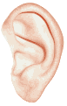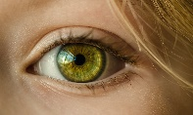A person who is deaf-blind cannot see or hear to some extent. This results in greater difficulties in accessing information and managing daily activities. Most people who are deaf-blind will be accompanied by an intervenor, a professional who helps with communicating. Intervenors are trained in special sign language that involves touching the hands of the guest in a two-hand, manual alphabet or finger spelling, and may guide and interpret for their guest.

* **Gain the guest's attention** before starting a conversation (tap the guest gently on the shoulder or arm).
* **Don't assume what a guest can or cannot do**. Some people who are deaf-blind have some sight or hearing, while others have neither.
* **Speak directly to your guest**, not to the intervenor.
* **Ask** whether your communication is understood.
* **Make sure** the guest has picked up all of their possessions before leaving.
* **Offer assistance** if the guest appears to be having difficulty locating a specific service area, washrooms or food services facilities.
* When guiding a deaf-blind person **approach the person with deaf-blindness from the front**:
* **Speak slowly** and **clearly**, if they do not respond to this, gently place your hand on their shoulder or hand and leave it there giving the person time to respond;
* Keep the person in **close to your body**, so that they can detect changes in direction;
* When approaching steps, pause slightly before you start to climb;
* Raise or lower your arm slightly to indicate a step in the relevant direction;
* When guiding through a narrow space, pass your guiding arm behind your back and the person will fall in single file behind you;
* When guiding to a chair, place their hand on the back of the chair, some may then locate the chair for themselves while others might like you to guide them further.
* **In case of emergency**, if the guest is not accompanied by an intervenor, draw an "x" on the guest’s back (this is the universal sign for emergency), and lead the guest away from the emergency situation.

# 9GUESTS WITH THEAutism Spectrum Disorder

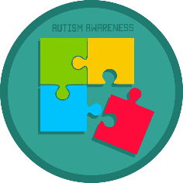Autism is known as a “spectrum” disorder because there is wide variation in the type and severity of symptoms people experience. It affects communication and behaviour. ASD occurs in all ethnic, racial, and economic groups. Although ASD can be a lifelong disorder, treatments and services can improve a person’s symptoms and ability to function.

* Address the individual by name first.
* Speak **directly**, **simply**, slowly and at a normal volume.
* **Try** to make eye contact, by positioning yourself in an eye-level.
* **Avoid broad open-ended questions**.
* **Provide a non-verbal communication** board if needed (like mobile phone, paper to write on, computer, etc.)
* If the guest is not bothering anyone with his/hers behaviour let the person do. They might present movements like rocking, quiet humming, pacing, wiggling, stimming, etc. For **self-regulation**.
* Offer a wristband or pass entry, because waiting sometimes can be very **overwhelming**.
* Behaviours you **should not ignore** are destructive activities, violent tantrums, loud or inappropriate interaction with other patrons, inappropriate sexual behaviour, and self-destructive behaviour.
* If there is a companion with the costumer you should **ask how you could help**, otherwise **talk clear and calm** to the costumer;
* Sit next to the person and offer help **without touching**;
* Offer to take the costumer to **quieter place**;
* If not able to help ask for others that might know how to help or call emergency;
* **Avoid** crowds, people touching and talking loudly next to the costumer.
* **Don’t be condescending** towards how the costumer talks/eat/interact.
* **Be aware of your own attitudes** and avoid being judgmental.
* If you can provide a **“quiet area”** at your establishment.
* It can be a small section cordoned off or a little room to one side away from all the noise and people, with pillows and sensory toys and furniture.
* This might seem like a small gesture but is a great support for individuals and families who do experience distress while they are out.
* It will allow the person to get away from a particular situation, cool down and collect themselves without having to leave, this can be especially good if there is loud music playing or if something happens, e.g. Smells, sounds, touching or a change in routine.

# 10DEALING WITH GUESTS WITH DISABILITIES OVER THE PHONE



* Speak **normally**, **clearly** and **directly**.
* Don’t worry about how their voice sounds. **Concentrate on what’s being said**.
* **Be patient**, **don’t interrupt** and **don’t finish your guest’s sentences**. Give your guest time to explain him/ herself.
* **Don’t try to guess** what your guest is saying. If you don’t understand, don’t pretend. Just ask again.
* If you’re not certain what was said, just **repeat or rephrase** what you’ve heard.
* If a telephone guest is using an interpreter or a TTY line, **just speak normally to the guest**, not to the interpreter.
* If your guest has great difficulty communicating, make arrangements to call back when it’s convenient to speak with someone else who can be of help.

# 11General information to provide a better service with any guest with Disabilities

* Treat people with disabilities with **respect** and **consideration**. Demonstrate that they presence matters like everyone else.
* **Patience**, **optimism**, and a **willingness** to find a way to communicate are your best tools.
* **Smile**, relax, and keep in mind that people with disabilities want to experience helpful guest service.
* Don’t make assumptions about what type of disability or disabilities a person has. Some disabilities are not visible. Take the time to get to know your guests’ needs.
* **Be patient**. People with some kinds of disabilities may take a little longer to understand and respond.
* If you’re not sure what to do, ask your guest, **“how may I help you?”**
* Do not assume that a person with a disability needs help. **Ask** the person whether they would like help, and then ask how you could help. Do not be offended if your help is not accepted: many people do not need any help.
* Find out—as early as possible—**how the person prefers to communicate**. If necessary, ask the person’s family member, career, or support person to explain how the person prefers to communicate, and to explain the person’s communication aids or devices. Let relevant colleagues know how the person communicates, so that the person does not have to repeatedly explain it.
* If you can’t understand what someone is saying, just **politely** ask again.
* **Ask before you offer to help** — don’t just jump in. Your guests with disabilities know if they need help and how you can provide it.
* Find a good way to communicate. A good start is to listen carefully.
* Look at your guest, but **don’t stare**. Speak directly to a person with a disability, not to their interpreter or someone who is with them.
* **Use plain language and speak in short sentences**.
* **Don’t touch or address service animals** – they are working and have to pay attention at all times.
* **Ask permission** before touching a wheelchair or a piece of equipment.
* **Do not assume** that a person with a disability is more fragile than others. Ask the questions that you need to ask.
* Every business should have emergency procedures for guests with disabilities. **Make sure you know what they are**.
* Instead of conclusion it is important to emphasize that functioning and active role in activities (touristic)of each person with disabilities or person who faced with barriers depends on what is accessible to him or her, and that the availability depends on the access and adequate support. Although the barriers and medical conditions in some ways are classified at least in harsh categories, adequate means of support is difficult to predict on the basis of information that we take from categories in which certain person is classified. It is necessary to know the person for the following reasons:
* People with the same medical diagnosis and the same medical condition largely function differently;
* People who face barriers know best how to overcome them, so do not hesitate to ask how to give a support;
* The same kind of support is not often adequate for the different people who are faced with the same type of barriers.



# References

Accessibility Advisory Committee, 2016.**Best Practices for Providing Assistance to Customers with Disabilities: A Resource Tool.**Accessed 27 November 2018.<<https://www.otc-cta.gc.ca/eng/publication/best-practices-providing-assistance-customers-disabilities-a-resource-tool>>

ACCESSIBLE ONTARIO CUSTOMER SERVICE, 2015.**Tips on Serving Customers with Disabilities**. Accessed 26 November 2018.<<http://www.keroul.qc.ca/DATA/PRATIQUEDOCUMENT/170_fr.pdf>>

Aged Care Crisis, 2015. **Vision impairment.** Accessed 29 November 2018. <https://www.agedcarecrisis.com/care-issues/vision-impairment>

Convention of the rights of persons with disabilities. Art 9. **Accessibility**. Accessed 14 December 2018.<<https://www.un.org/development/desa/disabilities/convention-on-the-rights-of-persons-with-disabilities/article-9-accessibility.html>>

Convention on the rights of Persons with disabilities, 1st Report - Belgium. **Position of the associations and Advisory Structures representing persons with disabilities**. 2014. Accessed 14 December 2018. <http://bdf.belgium.be/bdf_belgium_be/resource/static/files/pdf_uncrpd/2014-02-20---alternative-report---belgian-disability-forum.pdf>

CountryReports Travel Edition. 2018. **Disability Access In Belgium.** Accessed 14 December 2018. <https://www.countryreports.org/travel/Belgium/accessibility.htm>

CountryReports Travel Edition. 2018. **Disability Access In Bulgaria.** Accessed 14 December 2018. <https://www.countryreports.org/travel/Bulgaria/accessibility.htm>

CountryReports Travel Edition. 2018. **Disability Access In Serbia.** Accessed 14 December 2018. <https://www.countryreports.org/travel/Serbia/accessibility.htm>

CountryReports Travel Edition. 2018. **Disability Access In Turkey.** Accessed 14 December 2018. <https://www.countryreports.org/travel/Turkey/accessibility.htm>

Disabled World, 2015.**Physical & Mobility Impairments: Information & News.** Accessed 29 November 2018, <https://www.disabled-world.com/disability/types/mobility/>

Eoin O’Herlihy. **Access Handbook Template: A Tool to Help Manage Accessibility of the Built Environment**, 2005. Accessed 26 November 2018, < http://nda.ie/nda-files/Access-Handbook-Template1.pdf>

[National Disability Authority](http://www.nda.ie/), **Make your Service more accessible.** Accessed 26 November 2018.<<http://nda.ie/Resources/Accessibility-toolkit/Make-your-services-more-accessible/#polite>>

National Institute of Mental Health, **Autism Spectrum Disorder.** Accessed 29 November 2018.<https://www.nimh.nih.gov/health/topics/autism-spectrum-disorders-asd/index.shtml>

Sheena L. Carter, Ph.D. Department of Pediatrics, 2018, **Impairment, Disability and Handicap.** Accessed 29 November 2018. <<http://www.pediatrics.emory.edu/divisions/neonatology/dpc/Impairment%20MX.html>>